To Locate Keyframes in your Video
You could scrub your timeline under your Preview Window, and watch for you red diamond to pop up in your inspector.
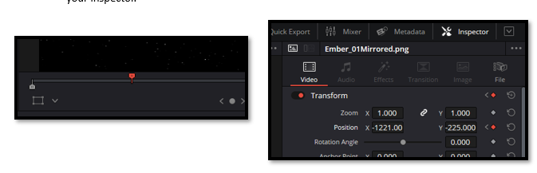

Keyframes Panel
But there is a better way. Open your keyframe panel. Upper left corner.
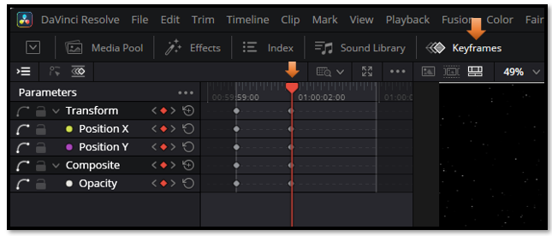

Deciding How to view your Keyframe Panel
At the top left of this panel, you will see some little icons. You can easily miss them if you are not really looking at them. But this gives you an option for how you want to view this panel.
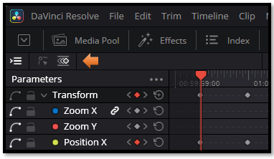
The first icon, give you your parameter list. If you turn it off you will only get your keyframes. You will have to select either the first or second icon. But you can turn off the list, if you do not wish to view it. Here we have the Curve graph selected. You will want this, if you are interested in giving the keyframes some easing in and out. And this you can give by using the icons, that are only visible with this icon selected.
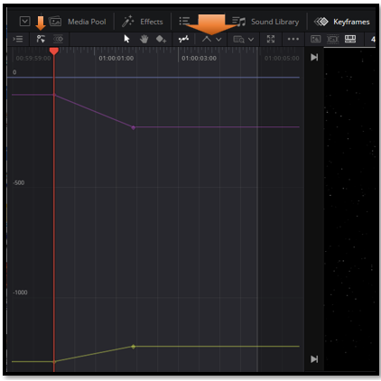
Draw select to embrace your keyframes on the chart and then click this button to get some easing.
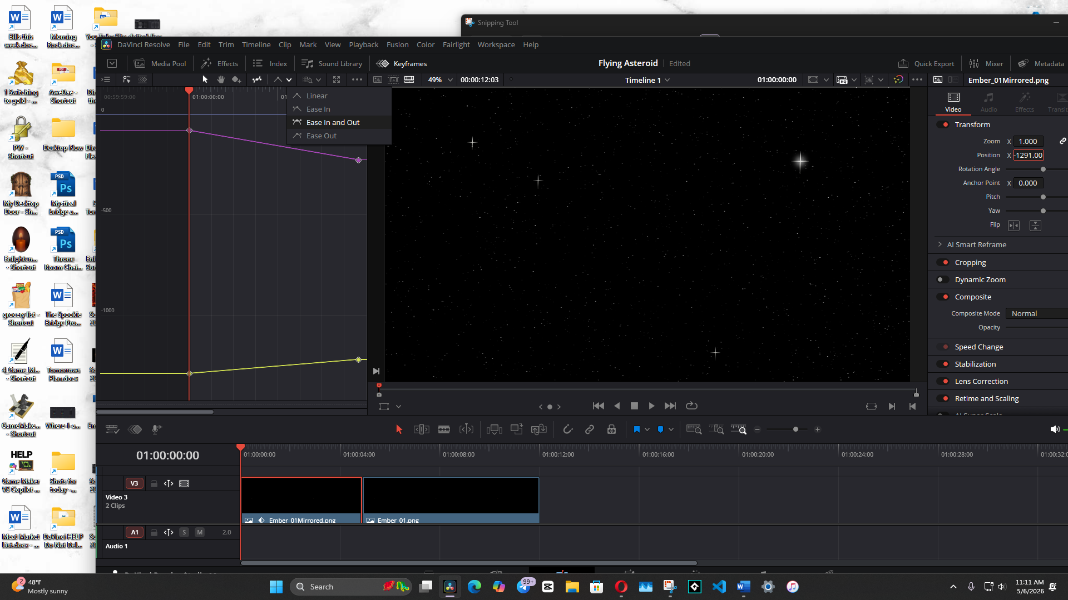
Now you can click on this icon, and go into Detail mode, or Full Extent Zoom. The slider will zoom you in or out.
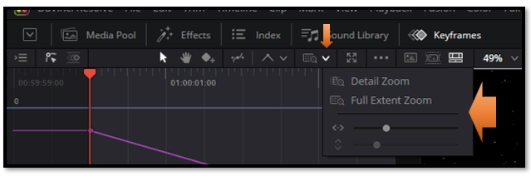

The Key Frame Icon
If I am not working with trying to ease my keyframes, this is a good panel to work with. I can zoom in on where all of my keyframes are located in the video all at once, and this can be very helpful.
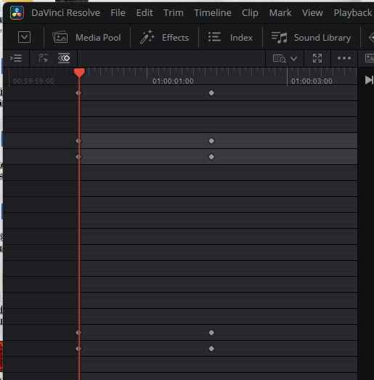

Turning Back on the Parameter list.
Just hit this icon again, and it can be used with either of the other 2 icons. So, you can view the names of the parameters you are working with, plus a visual of the keyframes.
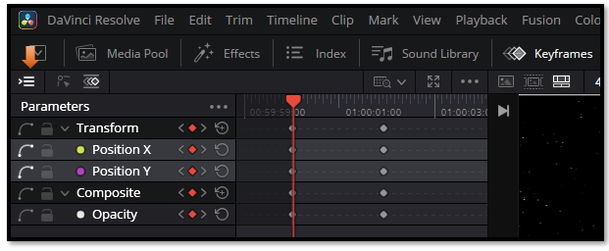
Here we have selected only to view the parameters(properties) that we actually have targeted by our keyframe. I only am working with Position X & Y, and the Opacity.

The Parameter List Hamburger Menu
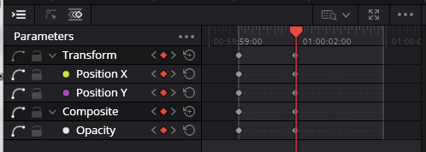
But we could choose to view all of our parameters by going to the 3 dot, hamburger menu above your parameter list.
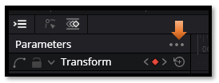
Now this here is a very useful menu, if you take a look at it. The first one, which I have selected shows me only what I want to see at the time, which is the keyframes that I am actually working with.
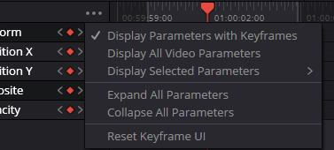
But let’s say, I might be adding some stuff to this list and I want to see what I have available to me. For that I would select Display All Video Parameters.

Yes, we might find this is a little much for what we would want most of the time.
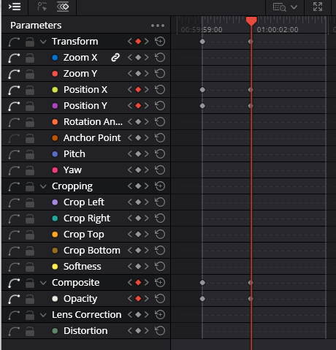

Here we can pick and choose what Parameters we want to choose.
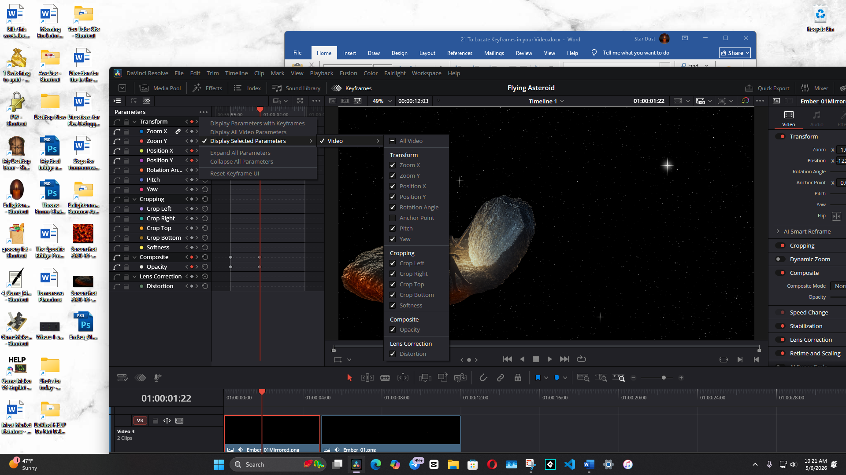
We can expand or collapse the parameters, I don’t really have anything here to expand, but if I did, I could.

To Delete all Keyframes
Unfortunately, that last option to reset Keyframe UI, will not erase your keyframes where you can start again. To erase the keyframes, you actually need to draw a square marquee around all of your keyframes and then delete them, manually
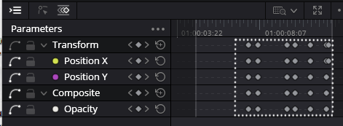
Then Reset the Position and Opacity back to their default settings.
